**ES 207 – Final Project – Draft Paper – Bennett Widyolar**

**Feasibility Study of Solar Powered Ground Water Pumps in the MGWB**

**Introduction**

The central valley in California is one of the largest irrigated agricultural areas in the United States and produces approximately $17 billion in agricultural revenue per year. In 2000, total ground-water withdrawals from the central valley aquifer were the second largest in the United States, at 9,810 with about 91 percent of total withdrawals for irrigation at a rate of approximately 8.910 billion [1]. Over time, this has resulted in significant lowering of the water table, land subsidence in some areas, and numerous other issues. Many groundwater pumps are located in remote locations and are thus powered by diesel motors which are inefficient and contribute to air quality issues. In this paper, I investigate the feasibility of powering groundwater extraction pumps with solar photo-voltaic (PV) panels.

**Sources of Data and Methods**

The data used in this analysis came from the California Department of Water Resources. Depth to water measurements from a total of 814 wells within the Merced Ground-Water Basin (MGWB) were used to determine the annual average depth to water for the MGWB from 1922 to 2015. Multiple measurements for a site during the same year were averaged and data prior to 1960 was not used due to inconsistency in measurements.



Figure 1 – Merced Ground-Water Basin and location of wells

The energy required to pump groundwater is a function of the total height it must be pumped. Calculations are performed based on the UC Water report [2] as follows:



where $kWh$ is kilowatt-hour; $TDH$ is the total dynamic head ($ft$); $AF$ is the acre-feet of water (Note: 1.0241 accounts for the conversion between units).

The total dynamic head (TDH) is calculated as:

$TDH = GWL + DD + CL + DP$,

where $GWL$ is the depth to groundwater level ($ft$); $DD$ = drawdown (ft); $CL$ = column loss ($ft$); and $DP$ = discharge pressure ($ft$). Drawdown, discharge pressure, and column loss are estimated based on information reported by Burt et al. (2003) [4] for the MGWB region (DWR ETo zones 12 and 15 [5]), as 25 $ft$, 9 $ft$, and 2.5 $ft$, respectively.

Total annual ground-water extraction from the MGWB is estimated based on 1990 data on land and water use by the DWR. Annual urban and agricultural extractions are estimated as 54,000 $af$ and 492,000 $af$, respectively. Other extractions equaled approximately 9,000 af for a total annual extraction of 555,000 [6]. Annual ground-water extraction was estimated in 2007 by MAGPI at a total of 683,250. Agricultural demand outside the Merced Irrigation District (MID) (and met with groundwater) totaled 595,000 $af$, groundwater pumping by MID totaled 13,000 $af$, municipal and private entities pumped approximately 50,250 $af$, and there was 25,000 $af$ groundwater makeup for surface water used for environmental purposes [7]. Based on these two reports, an annual extraction of 620,000 is used for ground water energy use calculations.

Most groundwater pumps are either diesel powered or electrically powered. Large diesel engines can have efficiencies up to $40\%$ during the conversion of chemical energy stored in the diesel into useful work. Large centrifugal pumps offer efficiencies from $75-93\%$. Thus a good diesel pump will generally operate near $35\%$ efficiency [10, 11]. On the other hand, large DC motors have efficiencies (electric to useful work) anywhere from $75-90\%$. Thus a good electric DC pump will operate near 75 percent overall efficiency. Overall pump efficiency in the MGWB region for on-farm groundwater pumping is reported as approximately $52\%$ [4], indicating a mix of diesel and electrically powered pumps with slightly more diesel pump capacity.

Merced County receives an annual daily average of solar insolation of 5.5 [3]. Assuming solar PV module efficiency of $20\%$ (solar to electric), an electric pump efficiency of $75\%$, and ignoring all storage losses and seasonal effects, the size of the solar field (aperture area) required to provide enough energy to meet the annual groundwater extraction energy demand can be calculated.

**Results**

The Merced Ground-Water Basin experiences roughly a 1 foot decline per year. This corresponds to a reduction of approximately 60 feet since the 1960s (and is well documented). As the energy required to lift water is linearly proportional to the elevation it is pumped, the solar panel area required to supply the power is linearly proportional to the depth to the water table. The percentage of the MGWB (491,000 acres) that would need to be covered by solar panels is listed on the secondary y-axis of Fig. 2. Points are predicted and plotted for 2025 and 2050.

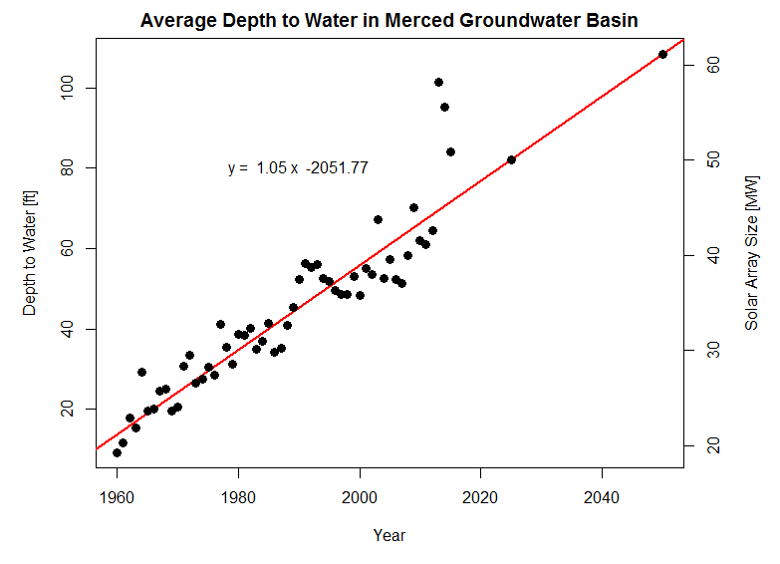

Figure 2 – Average depth to ground water for the Merced Ground-Water Basin

In 2015, to supply all the energy needed for groundwater extraction would have required 63 acres or a 51 MW solar array. Note: Current installed capacity in California is approximately 4,000 MW. The current cost of installed rooftop solar systems greater than 10 kW is $4.37 / watt [8].Thus, such a system would cost approximately $102 million. This does not include the cost of replacing existing diesel pumps with electric DC pumps.

Current groundwater is pumped by diesel and electrically powered pumps and a switch to solar generation would provide energy savings. Assuming current groundwater pumps are split 50/50 between diesel and electrically powered, this correspond to an annual energy cost of $7 million for electricity and $6 million for diesel for a total of $13 million in 2015.

In 2014, Merced County grossed $4.5 billion in agricultural commodities. The panel area required to meet the annual groundwater requirements would take up 0.01% of the MGWB surface area. This would cause a net loss of $225 million, assuming a 0.01% loss in agricultural commodity production simply due to land use change to solar PV energy generation.

|  |  |
| --- | --- |
| Cost of solar array | $102,000,000 |
| Cost savings (diesel / electrical) | $13,000,000 |
| Annual agricultural production lost | $443,000 |

Based on these assumptions, it would take roughly 8.5 years to pay back such a system (Did not do any financial calculations).

ANNUAL COST FOR EXPANSION DUE TO WATER TABLE REDUCTION (i.e. how many panels per year do you need to add?)

What is air quality improvement (i.e. C02 emissions saved?).

**References**

[1] Maupin, M.A., and Barber, N.L., 2005, Estimated withdrawals from principal aquifers in the United States, 2000: U.S. Geological Survey Circular 1279, 46 p.

[2] Tzou, D., 2015, Water and Energy Footprint Exercise: UC WATER Security and Sustainability Research Initiative, University of California, Merced, California

[3] Simons, G., and McCabe, J., 2005, California Solar Resources: CEC-500-2005-072-D

[4] Burt, C., D. Howes, Dan, and G. Wilson (2003). California Agricultural Water Electrical Energy Requirements, ITRC Report No. R03-006, Cal Poly State University, San Luis Obispo, CA.

[5] California Crop and Soil Evapotranspiration for Water Balances and Irrigation Scheduling/Design. ITRC Report No. R 03-001

[6] California Department of Water Resources. 2004. Bulletin 118. San Joaquin Valley Groundwater Basin Merced Subbasin. http://www.water.ca.gov/groundwater/bulletin118/basindescriptions/5-22.04.pdf

[7] Merced Groundwater Basin Groundwater Management Plan Update Merced County, CA. <http://www.water.ca.gov/groundwater/docs/GWMP/SJ-8_MAGPI_GWMP_2008.pdf>

[8] <https://www.californiasolarstatistics.ca.gov/>

[9] <http://www.forbes.com/sites/jamesconca/2015/07/30/which-is-cheaper-rooftop-solar-or-utility-scale-solar/#635085054f6d>

[10] <https://www.nswfarmers.org.au/__data/assets/pdf_file/0007/35854/Energy-Irrigation-Diesel-versus-electric-pumps.pdf>

[11] <http://www.pumpsandsystems.com/topics/pumps/pumps/centrifugal-pump-efficiency-what-efficiency>

Review:

The main point of this work is to address the feasibility of converting current “dirty” ground water pumping methods to clean-energy methods such as solar PV. Specifically, this work focuses on the Merced Ground Water Basin (MGWB), where agriculture is a main source of economic income. Some calculations regarding the work required to pump ground water in the (MGWB) are introduced and used to calculate the required area of solar panel arrays. Additionally, the linear proportional relationship of ground water depth to power required is extended to the linear proportional relationship of power output and solar PV array area. The economic cost-benefit of the switch from internal combustion (IC) powered pumps to solar PV powered pumps is briefly addressed.

This work is publishable, with the caveat that it needs some work to help drive the novel point home. The introduction should be extended to give a better background of the problem and why this feasibility calculation is necessary. Referencing some case-studies of utilizing solar PV to power ground water pumps would add to this work. Additionally, if would help if the author delved deeper into the cost-benefit analysis.